**Name: Muhammad Huzaifa**

**Roll No: SU92-BSAIM-S24-010**

**Section: 3A**

**Subject: AI LAB**

**Documentations:  
Task 1: LUHN Algorithm (Credit Card Number Validation)**

**Code Explanation:**

1. **LUHN_check(card_num) Function:**
   * Converts the card_num into a **list of digits**.
   * Reverses the digit list **(reverse_digits)** to start processing from the **rightmost** digit.
   * Iterates over the reversed digits:
     + **Doubles** every **second digit** **(i.e., at odd indices).**
     + If doubling a digit makes it **greater than 9**, subtract **9** from it.
   * Computes the **sum (check_sum)** of all digits.
   * If check_sum % 10 == 0, the card number is **valid**.
2. **Execution & Validation:**
   * A sample card number **"4532015112830366"** is checked using LUHN_check().
   * If valid, prints **"Valid Card Number",** otherwise **"Invalid Card Number".**
     + **OUTPUT:**

**Valid Card Number**

**-------------------------------------------------------------------------------------------------------------**

**Task 2: Remove Punctuation from a Given String:**

**Code Explanation:**

1. **Remove_Punctuation(text) Function:**
   * Iterates through each character in the input text.
   * If the character is **not** in the defined list of punctuation marks (.,!?;:-()[]{}@#$%^&*|\/), it is added to output.
   * Returns the cleaned string **without punctuation**.
2. **Execution:**
   * Takes user input for text.
   * Calls Remove_Punctuation(text) to remove punctuations.
   * Prints the cleaned text.

**Output:**

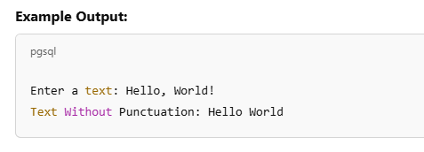

### **Task 3: Sort Words in a Sentence Alphabetically**

#### ****Code Explanation:****

1. **Sort_Sentence(sentence) Function:**
   * Splits the input sentence into a **list of words**.
   * Uses Python’s sorted() function to sort words **alphabetically**.
   * Joins the sorted words back into a **single string** and returns it.
2. **Execution:**
   * Takes user input for sentence.
   * Calls Sort_Sentence(sentence) to sort words.
   * Prints the sorted sentence.

**return “”.join(words)**

* This removes spaces between words.

**OUTPUT:**

